
Work Instruction for Configuration of chrony.conf with the new NTP IP and polling options

Viatris
Work Instruction for Configuration of chrony.conf with the new NTP IP and polling options

Contents
Contents 2
1. Introduction 3
1.1. Purpose 3
1.2. Scope of this Report 3
1.3. Audience 3
2. Approach and Methodology 3
2.1. Approach 3
2.1.1. Create a Change Request 3
2.1.2. Backup Existing Chrony Configuration file 3
2.1.3. Update Chrony Configuration file 3
2.1.4. Restart the chrony service 3
2.1.5. Confirm Change Approval 4
2.2. Methodology 4
2.2.1. Planning and Preparation 4
2.2.2. Required Details 4
2.2.3. Chrony Configuration 4
2.2.4. Post-Implementation Validation 5
2.2.5. Documentation and Compliance 5
2.2.6. Rollback Plan 5
3. Technical Details 5
3.1. Steps to migrate the chronyd 5
3.2. Steps to Migrate the ntpd Service 7
4. Roles and Responsibilities 9
5. Escalation Matrix 9
6. Revision History 10

1. Introduction

1.1. Purpose
This document provides the steps to migrate the NTP / Chrony in Linux servers

1.2. Scope of this Report
The scope of this document is to describe how we have migrated chrony/NTP servers regionally for all the Linux servers.

1.3. Audience
GIDC UNIX Group

2. Approach and Methodology

Approach

2.1.1. Create a Change Request
- Create a Change Request (CR) in ServiceNow for updating the new NTP server in /etc/chrony.conf file.

2.1.2. Backup Existing Chrony Configuration file
- Backup the current chrony configuration rules located in /etc/chrony.conf

2.1.3. Update Chrony Configuration file
- Add new ntp server entries in the /etc/chrony.conf file and delete the old ntp server entries.

2.1.4. Restart the chrony service
- Restart the chrony service to affect the changes.

2.1.5. Confirm Change Approval
- Ensure that the change management process is completed and the change request is approved for implementation.

Methodology

2.2.1. Planning and Preparation
- Change Request (CR): Create and document a CR in ServiceNow with all relevant details and obtain approvals.

2.2.2. Required Details
- The NTP server has been upgraded from the old NTP server to new regional NTP servers (US, EMEA, and APAC). This modification was done on the all the linux servers
Old NTP Server:
- server ntp1.myl.com
- server ntp2.myl.com
New NTP Server:
- server 172.20.25.231
- server 172.26.208.10
- server 10.250.26.17
- server 10.250.26.18
- server 10.248.21.57
- server 172.28.135.37

2.2.3. Chrony Configuration
- Update Chrony file:
Update the new ntp server entries in chrony.conf file and delete the old ntp server entries

- Apply Changes:
Restart the chrony services to affect the changes.

2.2.4. Post-Implementation Validation
Check the status of chrony services after implementation.

2.2.5. Documentation and Compliance
1. Document the implementation process with detailed steps, commands, and screenshots where applicable.
2. Ensure compliance with organizational change management and auditing requirements.

2.2.6. Rollback Plan
Maintain a clear rollback plan, leveraging the backups of the chrony configuration file and removing the newly added entries if required.

Technical Details

Steps to migrate to chronyd
1. Login to the Server using MID and password and switch to root user using sudo su – command.
2. Check if the chronyd service is running by using the following command
# systemctl status chronyd.service
3. If it is not running, start and enable the service:
# systemctl start chronyd.service
# systemctl enable chronyd.service

4. Verify the currently configured NTP server details using # chronyc sources
5. Take a backup of the /etc/chrony.conf file before making any changes:
# cp -pr /etc/chrony.conf /etc/chrony.conf_$(date +%F)
6. Open /etc/chrony.conf in a text editor (e.g., vi or vim) and comment out the old NTP server entry by placing a # at the beginning of the line:
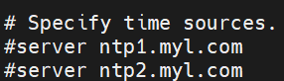
7. Add the new NTP server entry in the /etc/chrony.conf file
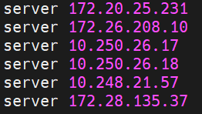
8. Restart the chronyd service to apply the changes with below command
# systemctl restart chronyd.service
9. Verify the service status with below command
# systemctl status chronyd.service
10. Validate the NTP Synchronization with below command
# chronyc sources
11. If everything is working correctly, you should see output indicating successful synchronization with the new NTP server like below. If not, review the steps and ensure each was performed correctly
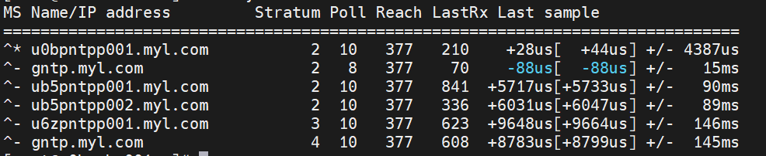

OR

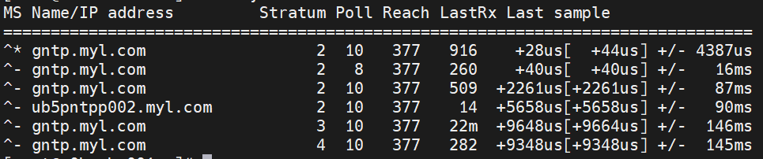

Steps to Migrate the ntpd Service
1. Login to the desired Server using MID and password and switch to root user using sudo su – command.
2. Check if the ntpd service is running with the following command
# systemctl status ntpd.service
3. If it is not running, start and enable the service:
# systemctl start ntpd.service
# systemctl enable ntpd.service
4. Verify the currently configured NTP servers using # ntpq -p
5. Take a backup of the /etc/ntp.conf file before making any modifications:
# cp -pr /etc/ntp.conf /etc/ntp.conf_$(date +%F)
6. Open /etc/ntp.conf in a text editor (e.g., vi or vim) and comment out the old NTP server entry:
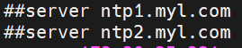
7. Add the new NTP server entry in the /etc/ntp.conf file
8. Restart the ntpd service to apply the changes with below command
# systemctl restart ntpd.service
9. Verify the service status with below command
# systemctl status ntpd.service
10. Validate the NTP Synchronization with below command
# ntpq -p
11. If everything is working correctly, you should see output indicating successful synchronization with the new NTP server like below. If not, review the steps and ensure each was performed correctly

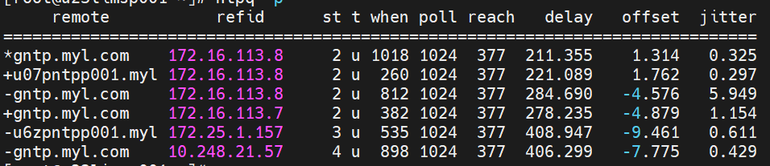
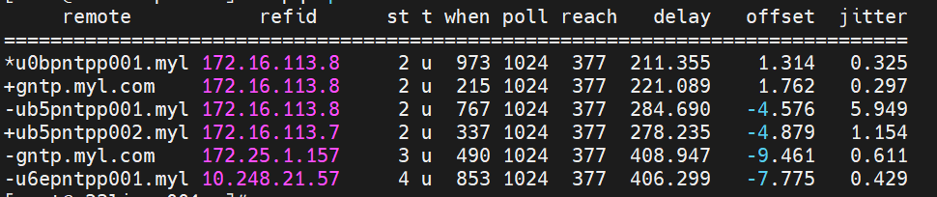
OR

Roles and Responsibilities
Sl. No. | Roles | Responsibilities | Team Member Name
1. | Change Request | Respective Team / Unix Team | GIDC.unix_Run  GIDC.unix_Run@viatris.com
2. | Change Implementation | Respective Team / Unix Team | GIDC.unix_Run  GIDC.unix_Run@viatris.com

Escalation Matrix
Person Responsible | Role | Triggers When
Arun R  Arun.R@viatris.com  +91 9710677240 | Deputy Manager
Ashok Kumar R K  AshokKumar.RK@viatris.com  +91 9967735890 | Senior Manager
Zahir Hussain M ZahirHussain.M@viatris.com  +91 9840689462 | Senior Manager

6. Revision History

Date | Version | Summary of Changes | Author | Approved by
April 28 2025 | V1.0 | Created the Document | Benesh Selva Nesan P | Arun R
April 28 2026 | V1.1 | Validated the Document | Benesh Selva Nesan P | Arun R

